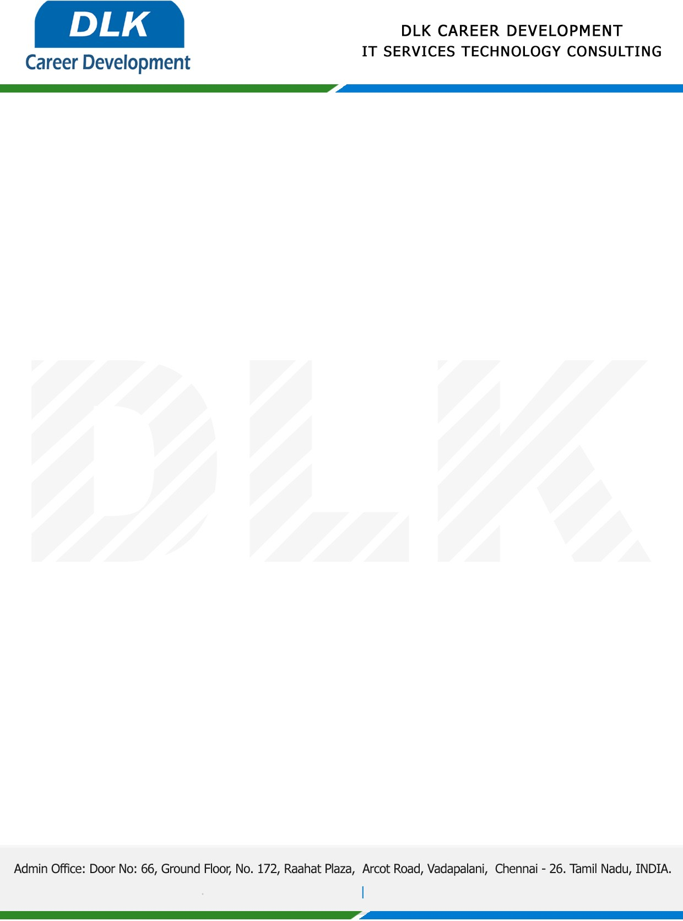

Date: 01/December/ 2022

**To**

Department of [M.SC](http://M.SC) ([Computer Science),](https://www.cseindia.org/)

Head of Department,

SRI SANKARA ARTS AND SCIENCE COLLEGE.

**Sub: Letter of Project Acceptance**

This is to certify that **MR SURENDAR V (REG NO:** **2101212078020)** that final year student of has Acceptance his Project Work duration from **02 December 2022 to 09 March 2023** under the domain **“Python”.** During the internship, all information and data collected from you should be kept confidential.

**Topic:** HELMET AND NUMBER PLATE DETECTION OF MOTORCYCLISTS USING PYTHON

We appreciate your interest in **DLK CAREER DEVELOPMENT**

